Bullhorn Technical Assignment

Task 1 – Account Score Calculation

Configuration Guide for Admins and Developers

Author: S. Saravana Kumar, Created on 12-01-2021

|  |  |  |
| --- | --- | --- |
| **Last Modified Date** | **Last Modified by** | **Release Status** |
| 13-01-2021 | Saravana Kumar | Released |
|  |  |  |

Contents

Account Score Calculation Introduction 2

Admin Configuration Guide 2

How to Open Custom Settings 2

Introduction to Custom Settings Order of Execution 3

How to Configure Modes 4

User Level 4

Profile Level 5

Org Level 6

View All Records in Custom Settings 8

Developer Guide 9

How to Execute the Account Calculation Logic 9

How to Create Apex Class to Calculate Account Score in Custom Mode 11

# Account Score Calculation Introduction

An admin user should be able to pass the 15- or 18- digit salesforce account record Id to an apex method to calculate the Account Score. There should be three modes available for the admin user to configure and execute the logic. The modes are given below,

1. *Default* – will use the standard field **Account Revenue**
2. *Advance* – will use the custom field **Custom_Field1__c**
3. *Custom* – will use a custom logic going to defined by subscriber / customer. An apex class can be created and used for custom account score calculation

Let’s see how to configure the modes below for a Profile, User or Org wide

# Admin Configuration Guide

## How to Open Custom Settings

1. Login to the Salesforce instance.
2. Go to **Setup.** 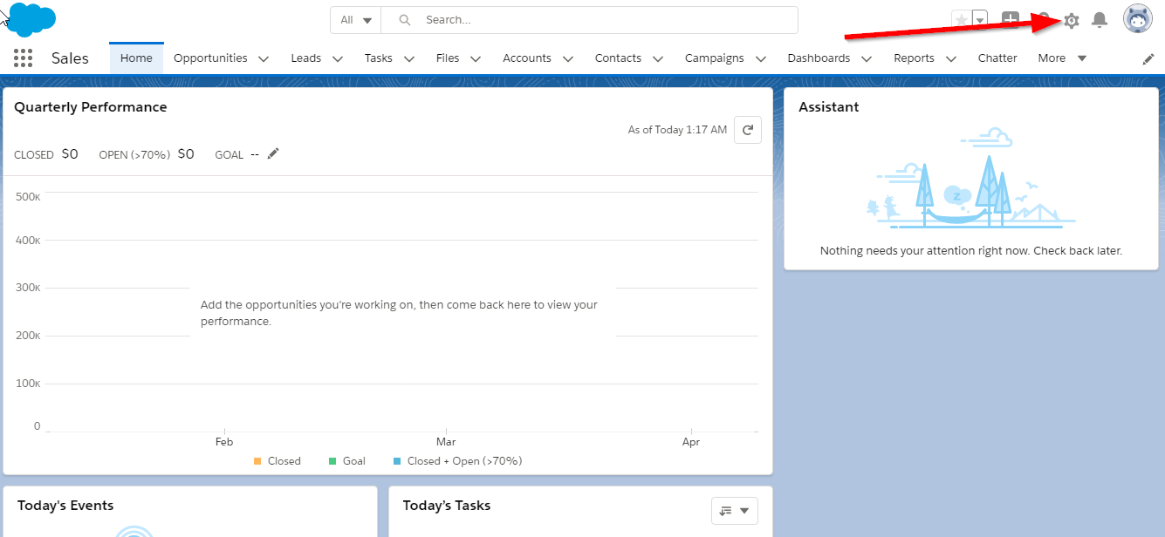
3. Type “*Custom Settings*” in the quick find search box on the left pane under salesforce logo.

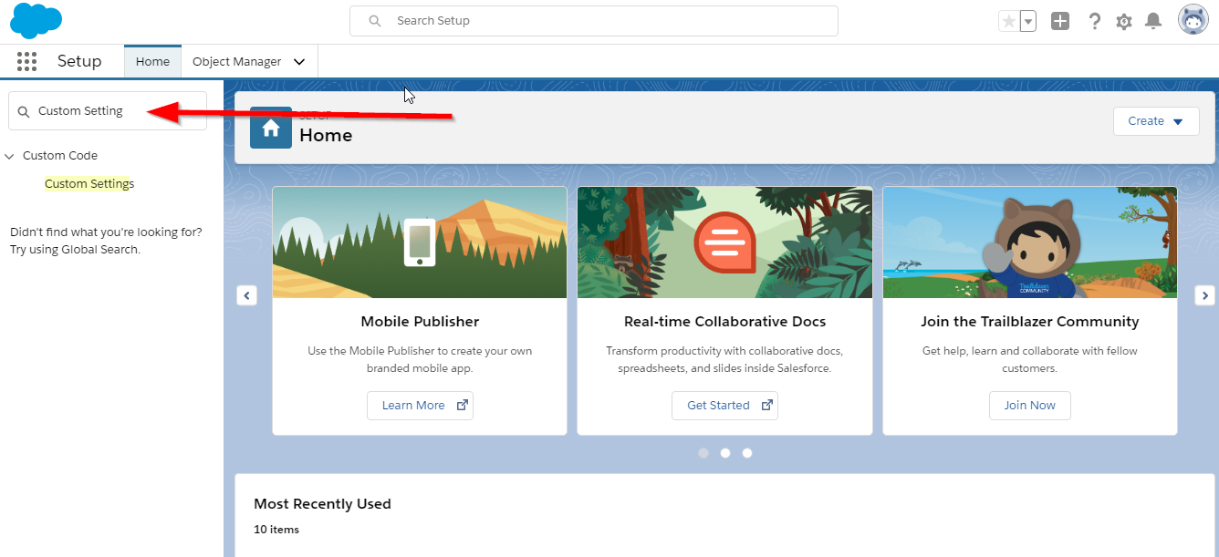

1. Click **Custom Setting.**

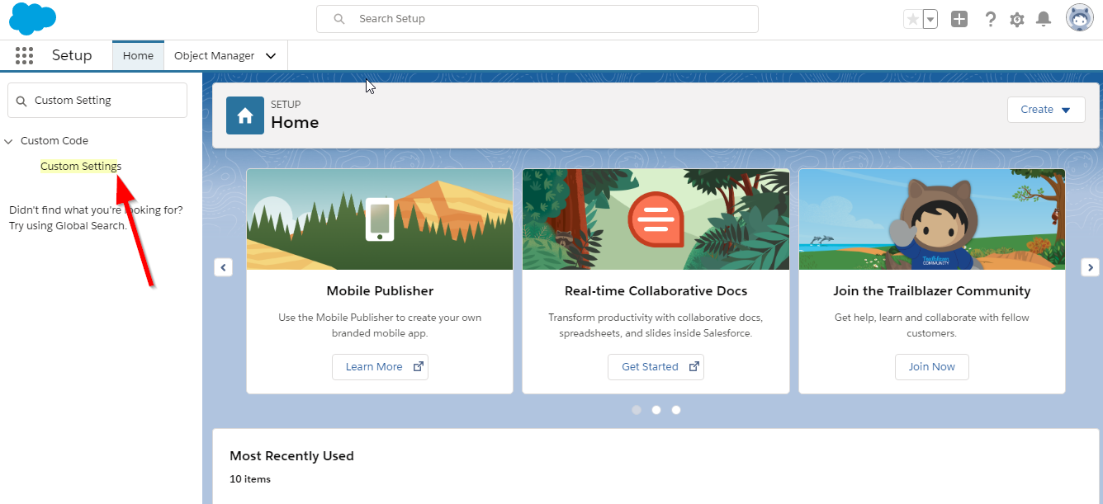

1. If your org has more than one custom setting, kindly search the “*Account Score Calculation Configuration*”by filtering using thealphabets on the right and click **Manage** hyperlink related to it.

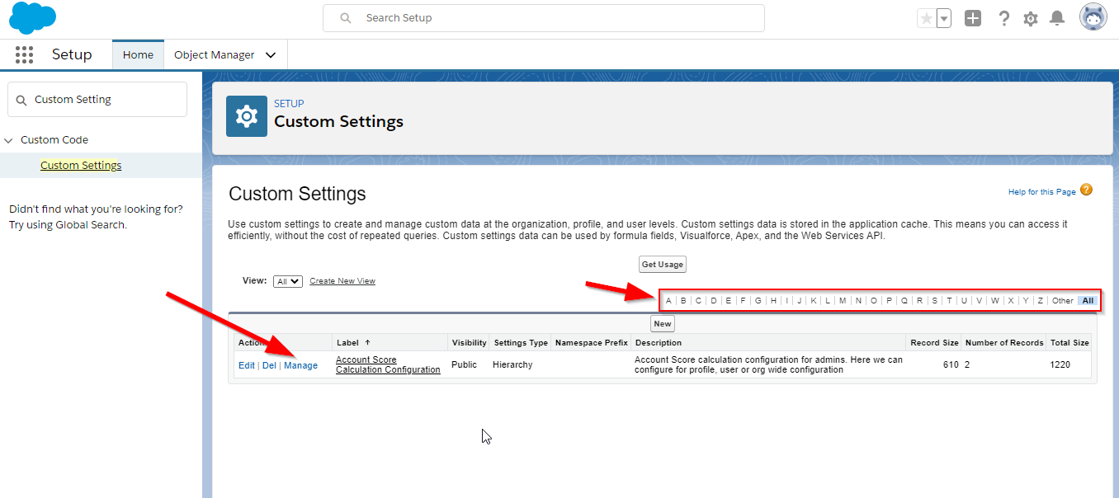

## Introduction to Custom Settings Order of Execution

Priority will be given to the custom settings configuration in the below order.

1. User level – first the system will check for user level configuration, if not present then the next level.
2. Profile level – second the system will check for profile level configuration, if not present then the next level.
3. Org level – if the above are not present, system will take the configuration from org wide.

Note: if any of the above is not present, system will take the **Default** mode for calculation

## How to Configure Modes

After clicking **Manage** hyperlink related to **Account Score Configuration Settings** incustomsettings. The below screen will appear. Click on second **New** button as pointed in the below image.

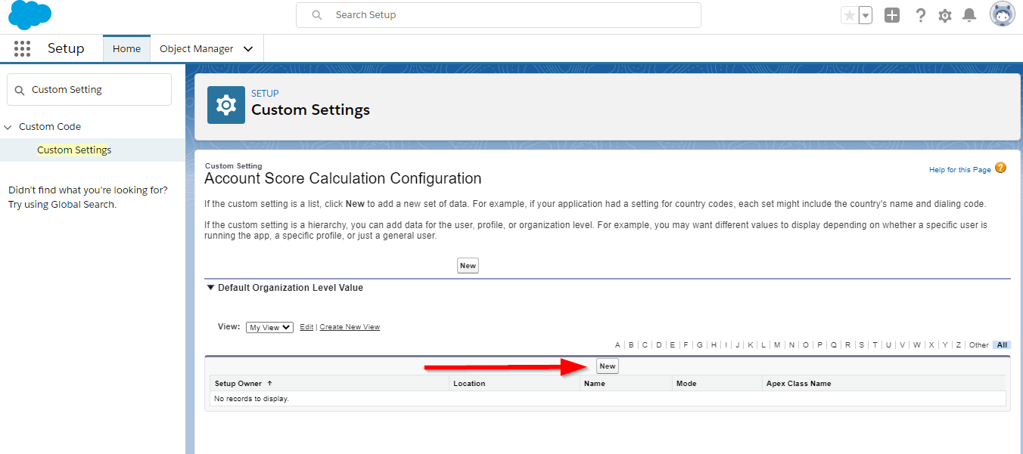

### User Level

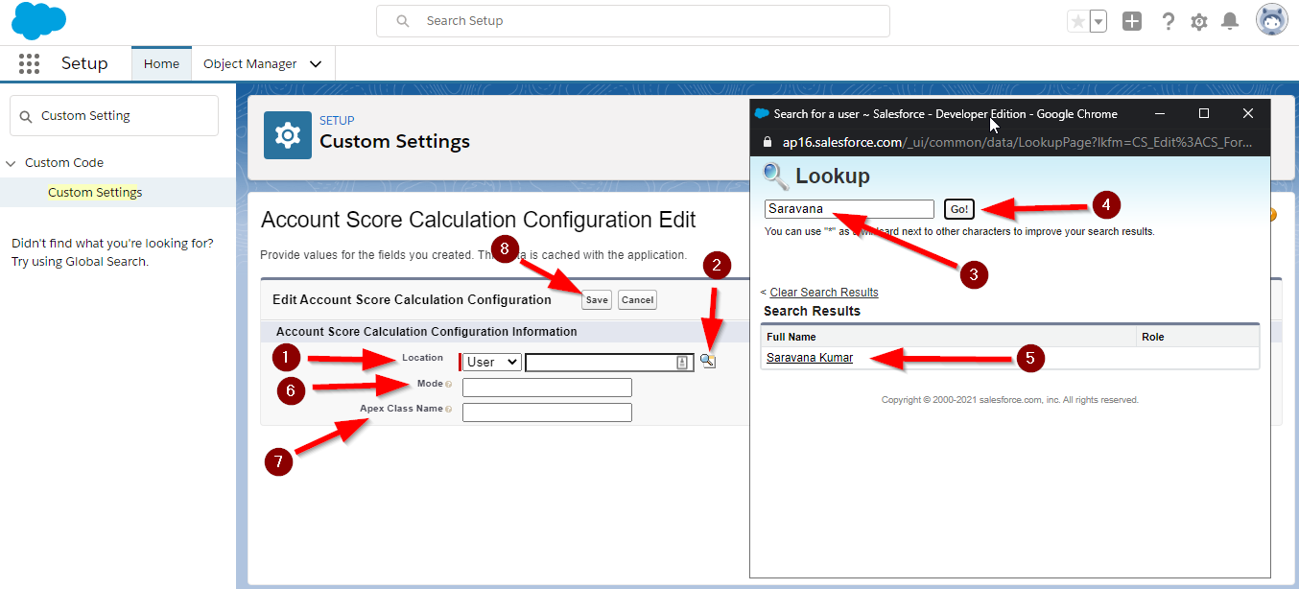

1. Select “*User***”** from the **Location** dropdown pointed as 1st step in the above image.
2. Click the lookup icon pointed as 2nd step in the above image.
3. A lookup dialog box appears on screen as shown in the above image.
4. Search the user in the search box in the dialog box pointed as 3rd step in the above image.
5. Click **Go** pointed as 4th step in the above image, the user list will appear below related to the search key.
6. Select the user from the list pointed as 5th step in the above image.
7. Enter the mode “*Default*” or “*Advance*” or “*Custom*”, kindly ensure the words are not misspelled. Pointed as 6th step in the above image
8. If the mode is “*Default*” or “*Advance*”,
   1. Leave the **Apex Class Name** field **blank,** pointed as 7th step in the above image.
   2. For,” Advance” please configure the Field API for calculation from Account object.
9. If mode is “*Custom*”
   1. Get the **Apex Class Name** from the developer which has the custom **Account Score** calculation logic.
   2. Enter the **Apex Class Name** in the **Apex Class Name** field, pointed in 7th step in the above image.
10. Click **Save** pointed as 8th step in the above image.
11. The below screen will appear after creating a record in custom settings, you can click **Back to List** hyperlink to see the all the records in custom settings in list view.

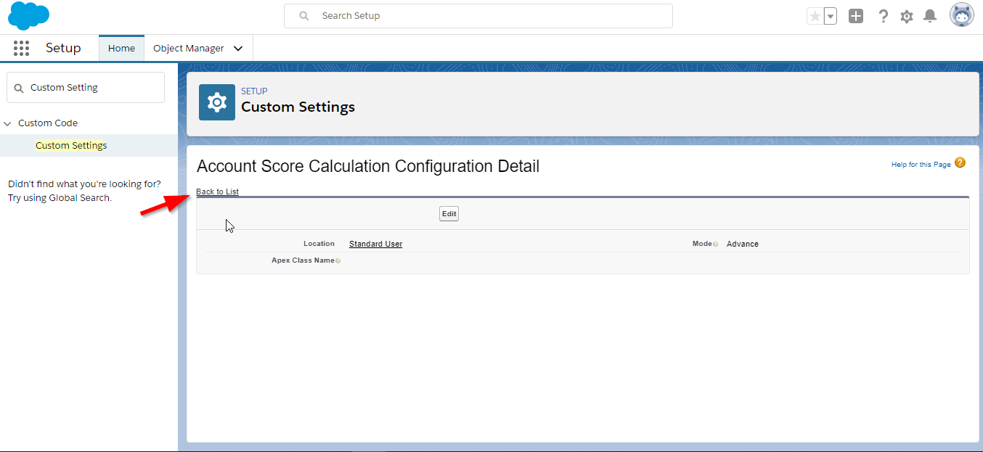

### Profile Level

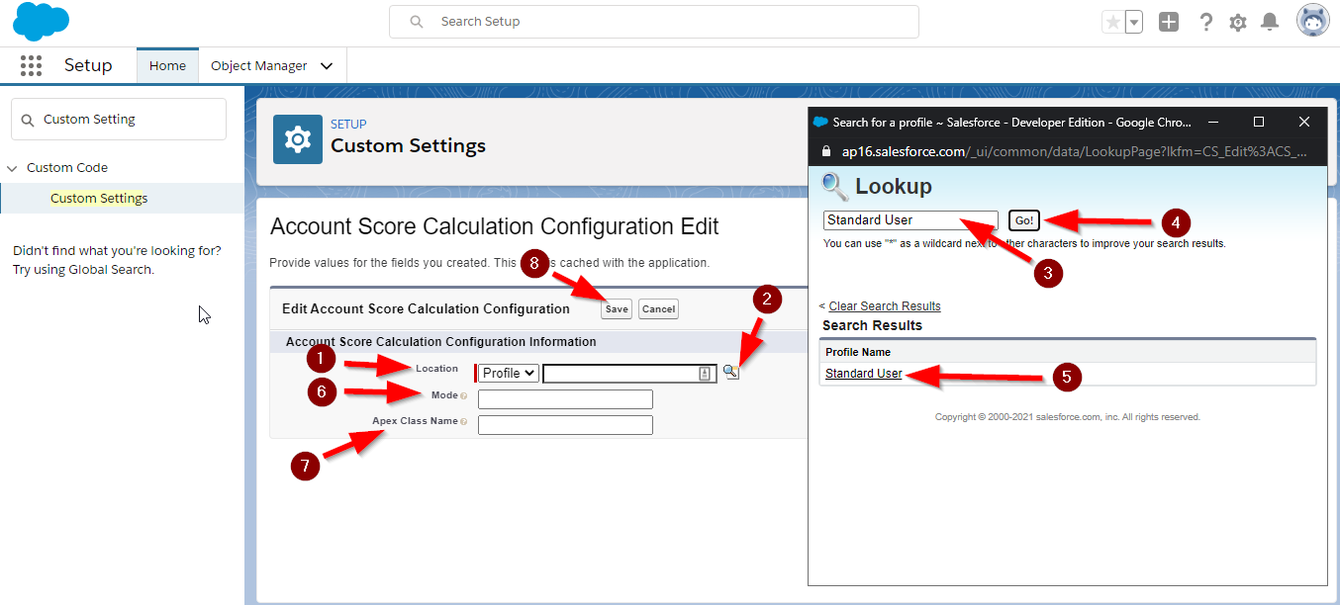

1. Select “*Profile***”** from the **Location** dropdown pointed as 1st step in the above image.
2. Click the lookup icon pointed as 2nd step in the above image.
3. A lookup dialog box appears on screen as shown in the above image.
4. Search the profile in the search box in the dialog box pointed as 3rd step in the above image.
5. Click **Go** pointed as 4th step in the above image, the profile list will appear below related to the search key.
6. Select the profile from the list pointed as 5th step in the above image.
7. Enter the mode “*Default*” or “*Advance*” or “*Custom*”, kindly ensure the words are not misspelled. Pointed as 6th step in the above image
8. If the mode is “*Default*” or “*Advance*”,
   1. Leave the **Apex Class Name** field **blank,** pointed as 7th step in the above image.
   2. For,” Advance” please configure the Field API for calculation from Account object.
9. If mode is “*Custom*”
   1. Get the **Apex Class Name** from the developer which has the custom **Account Score** calculation logic.
   2. Enter the **Apex Class Name** in the **Apex Class Name** field, pointed in 7th step in the above image.
10. Click **Save** pointed as 8th step in the above image.
11. The below screen will appear after creating a record in custom settings, you can click **Back to List** hyperlink to see the all the records in custom settings in list view.



### Org Level

In **Account Score Calculation Configuration** custom setting page, click on first **New** button pointed in the below image.

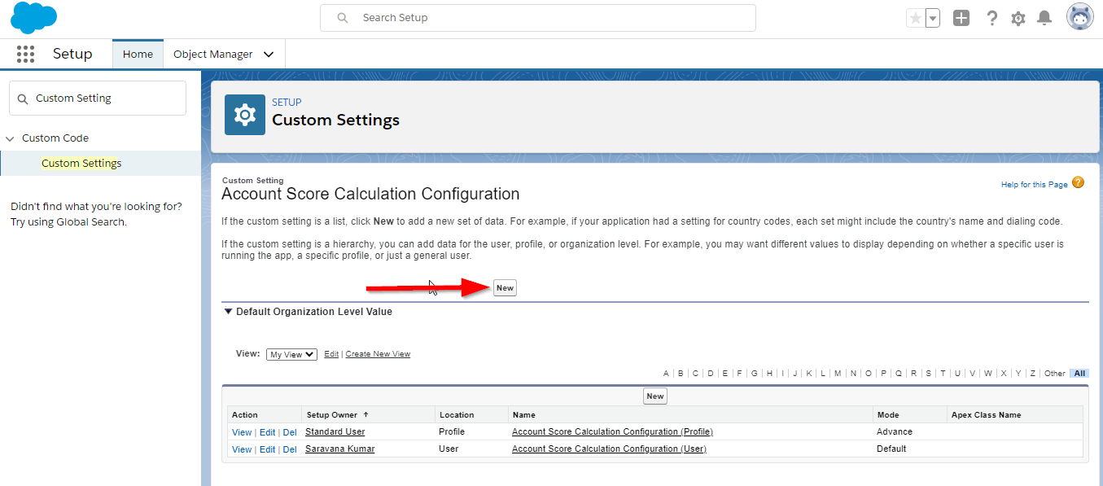

1. The below page will appear after the **New** button click.

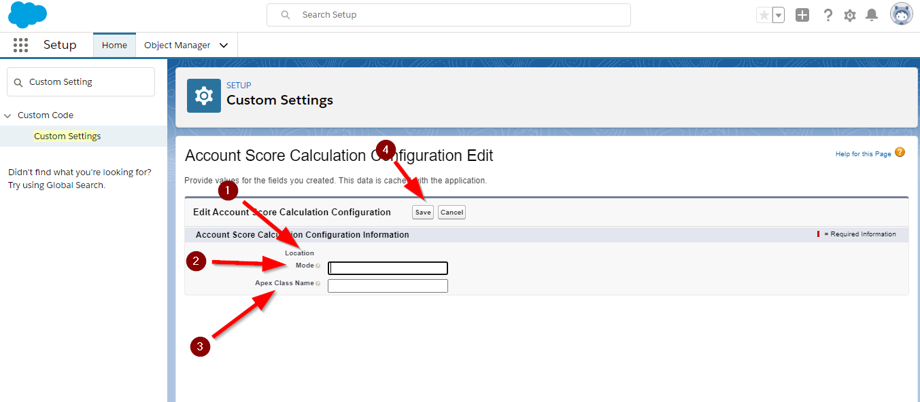

1. The **Location** field is disabled as this is an Org Wide configuration pointed in 1st arrow in the above image.
2. Enter the mode “*Default*” or “*Advance*” or “*Custom*”, kindly ensure the words are not misspelled. Pointed as 2nd arrow in the above image.
3. If the mode is “*Default*” or “*Advance*”,
   1. Leave the **Apex Class Name** field **blank,** pointed as 3rd step in the above image.
   2. For,” Advance” please configure the Field API for calculation from Account object.
4. If mode is “*Custom*”
   1. Get the **Apex Class Name** from the developer which has the custom **Account Score** calculation logic.
   2. Enter the **Apex Class Name** in the **Apex Class Name** field, pointed in 3rd step in the above image.
5. Click **Save** pointed as 4th step in the above image.
6. The below screen will appear after creating a record in custom settings, you can click **Back to List** hyperlink to see the all the records in custom settings in list view.

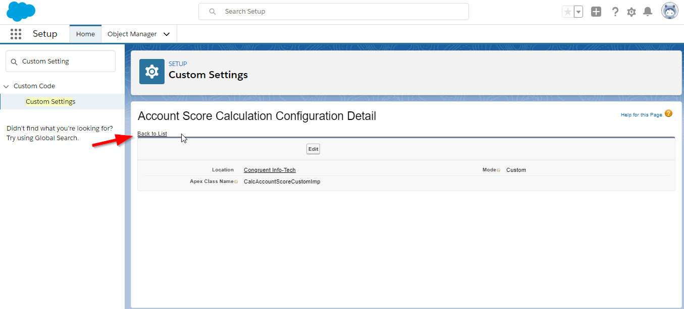

## View All Records in Custom Settings

1. Once the data creation is done, you can click on the **Back to List** hyperlink to view all records created so far.



1. You can even click **Manage** hyperlink related to **Account Score Calculation Configuration** custom setting



1. The custom setting records will look like the below image, here there are only three configurations
   1. For **Standard User** profile
   2. For **Saravana Kumar** user and
   3. Org Wide
2. In your org, it may have more than what shown in the below image – please check the next page if image is not visible

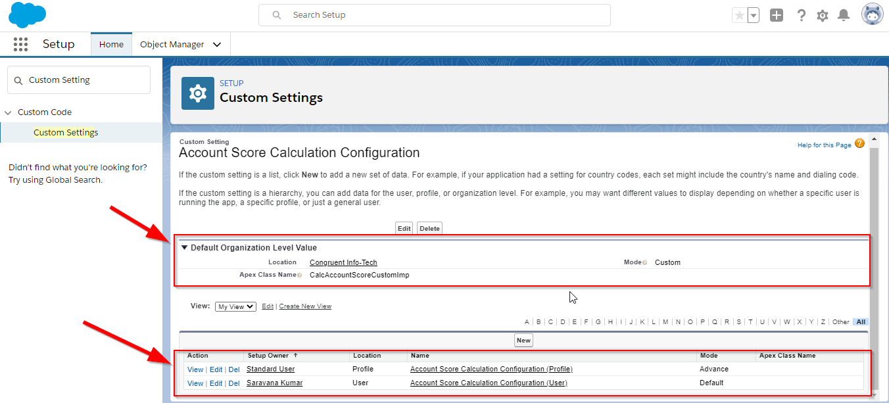

# Developer Guide

Kindly check the Account Score Calculation Introduction section before starting the development.

In the “Custom” mode configuration, an apex class from the subscriber / customer org can be used for custom Account Score calculation. Yet there is a way to create an apex class and make use of it with the existing flow but let’s take a look at how the execute the **Account Calculation** logic.

## How to Execute the Account Calculation Logic

1. Open the org
2. Go to **Developer Console**

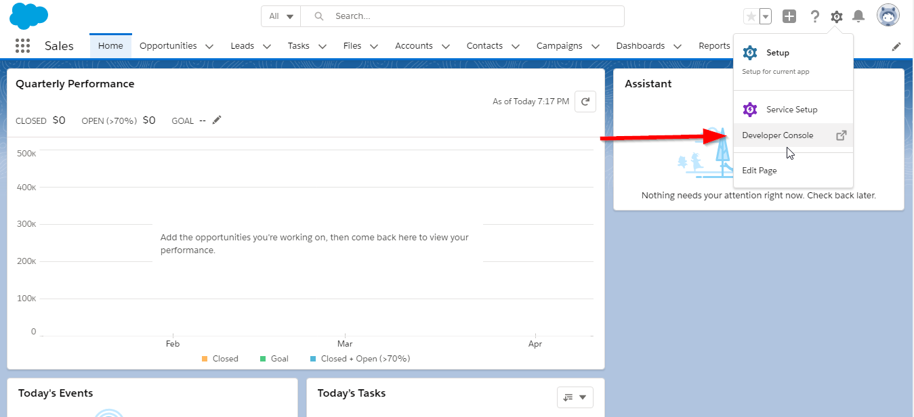

*Please check the next page*

1. Open **Execute Anonymous Window**

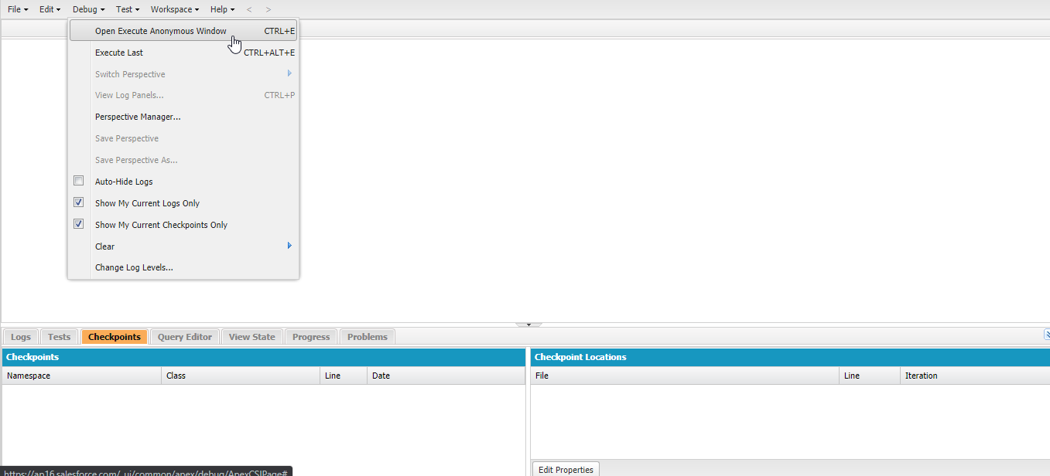

1. Copy and paste the below snippet and pass the Salesforce 15- or 18- digit record id of an account record in the org and execute. Check the **Logs** for the output.

**Snippet******

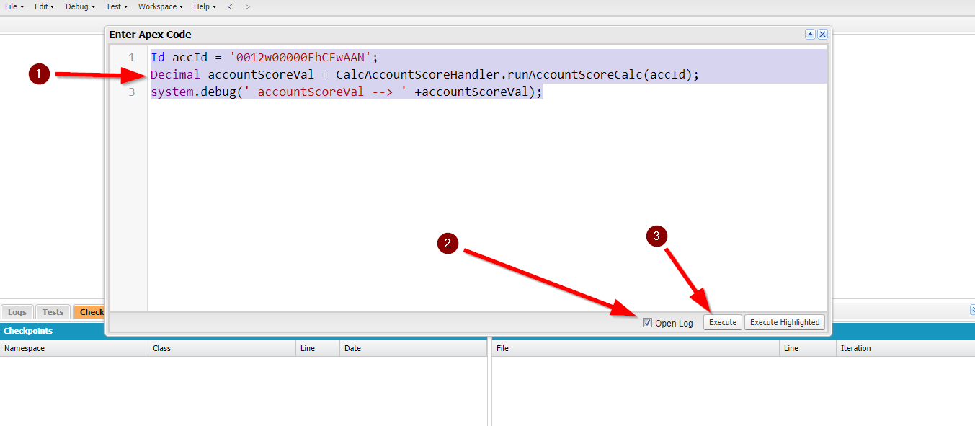

1. The steps can also be done from **VS Code**

Please check the next page

1. Once execution is done, the below log will open and tick the **Debug Only** checkbox and check the printed Account Score value
   1. Here the configuration for the user is “Advance”
   2. The value from the Custom_Field1__c is taken into calculation
   3. Formula for standard calculation is (Field Value/10) so the value of the Custom_Field1__c is 5000 and the output is 5000

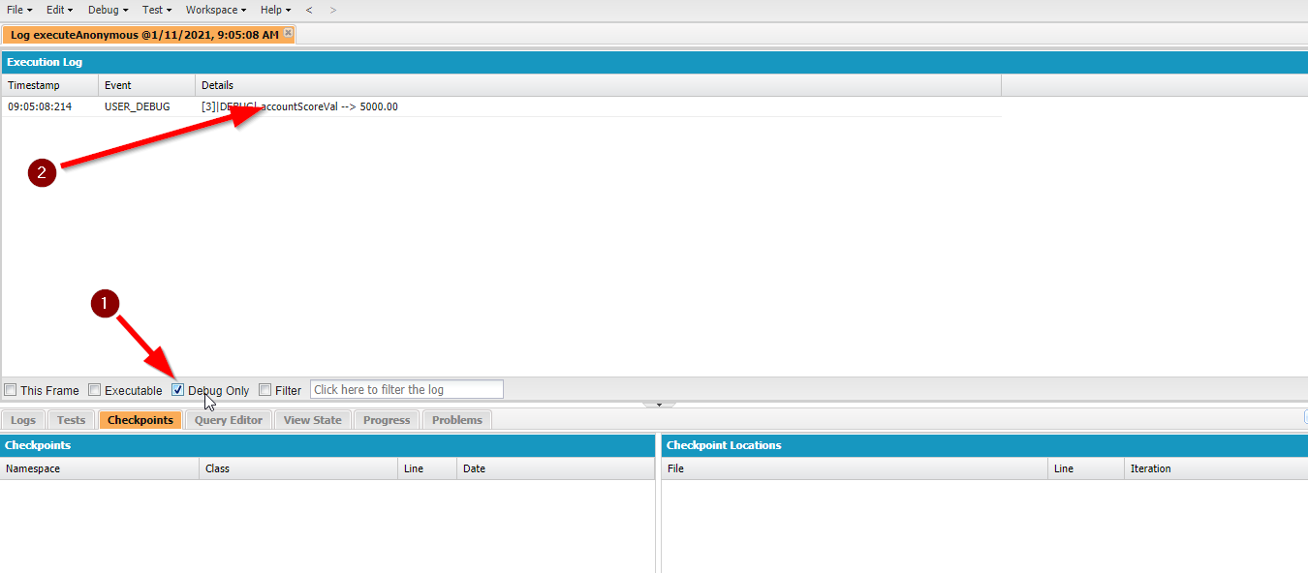

1. Let’s see how to create Apex Class for custom mode

## How to Create Apex Class to Calculate Account Score in Custom Mode

1. Create an **Apex Class** from the developer console or VS code

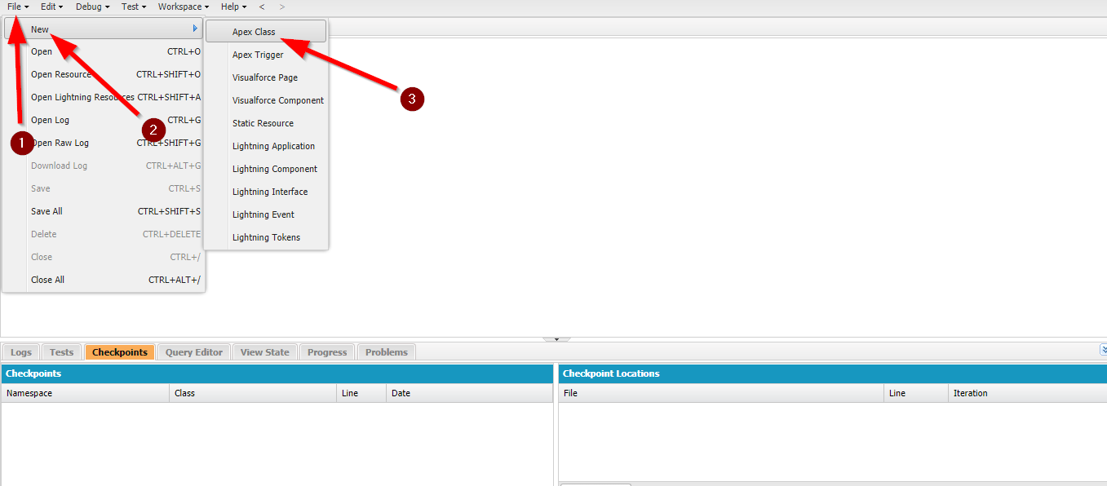

*Please check the next page*

1. Enter the apex class **Name**

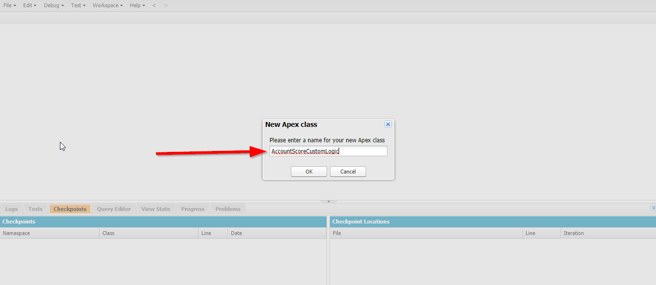

1. In the new apex class has to implements the interface class “*CalcAccountScoreInterface*” and create the signature method “*CalcAccountScore*” which should have return type of “*Decimal*”. Please check below sample apex class and double click to open the file.



1. In the above apex class, “*Param.accountRecord*” provides the Account record details which will have all the field value in below data types.
   1. Number
   2. Currency
2. Based on the field values the custom logic for account score calculation can be build.
3. In the above sample code, we used **Account_Revenue_Custom_Imp__c** filed for calculation.
4. To the test apex class, kindly check with the admin team to configure it in “*Custom*” mode or check the Admin Configuration Guide to configure the class in custom setting.
5. Once the configuration is done, please follow the steps given in the How to Execute the Account Calculation Logic to test the output.

Thank you!